Research

Mad Scientist Time

**Yey, So I Redesigned the Facebook Web Platform Home Page … — an Improved Design 2**

**Australian Super 3**

**Joining a Club on adelaide.edu.au 5**

**Log in and Sign up 10**

# Yey, So I Redesigned the Facebook Web Platform Home Page … — an Improved Design

<https://yolansihombing77.medium.com/yey-so-i-redesigned-the-facebook-web-platform-home-page-an-improved-design-9e89d3c2b78c>

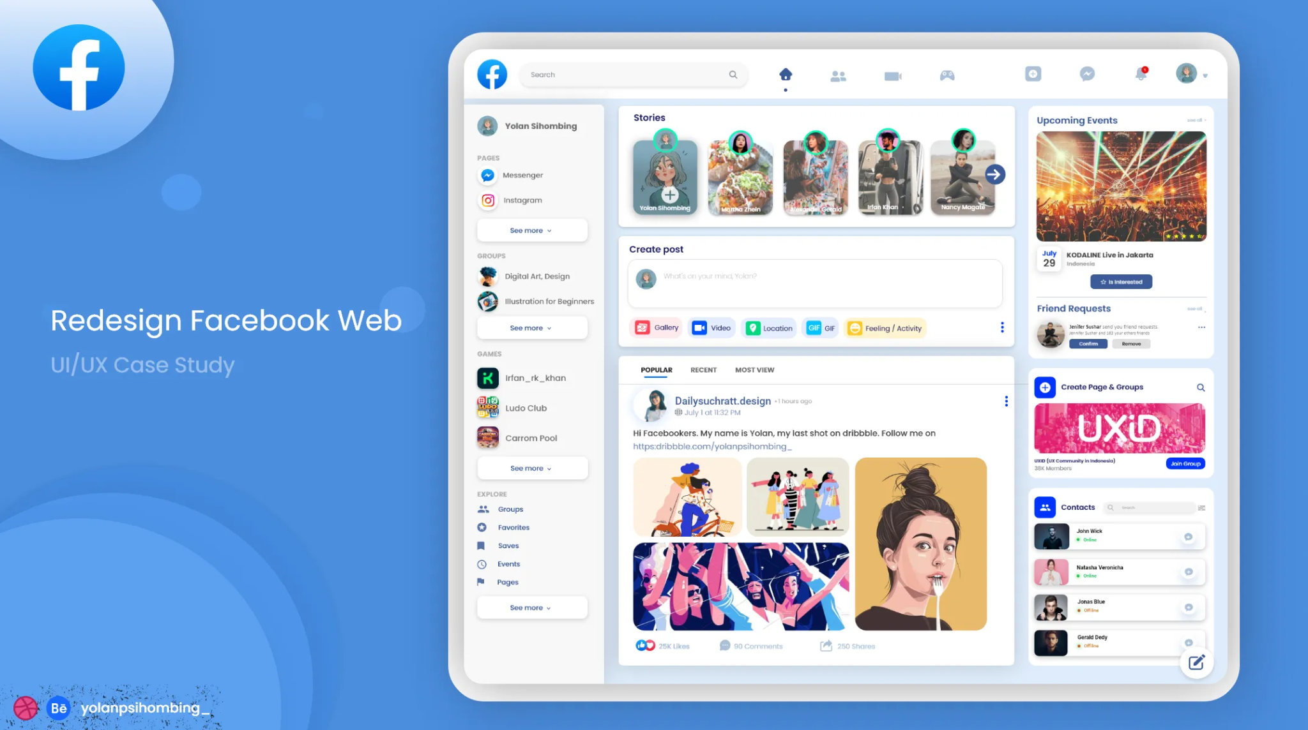

Important elements are large and in the center, easy to reach and interact with.

Related things sit on the side in a way that is easy to find and interact with.

Clear and easy to the eyes layout.

Design wise it seems very applicable to mobile devices, specifically something with a large screen like an iPad. Computers also seems like they would work well with this. However small devices like phones may feel a little cramped.

# 

# Australian Super

<https://www.australiansuper.com/>

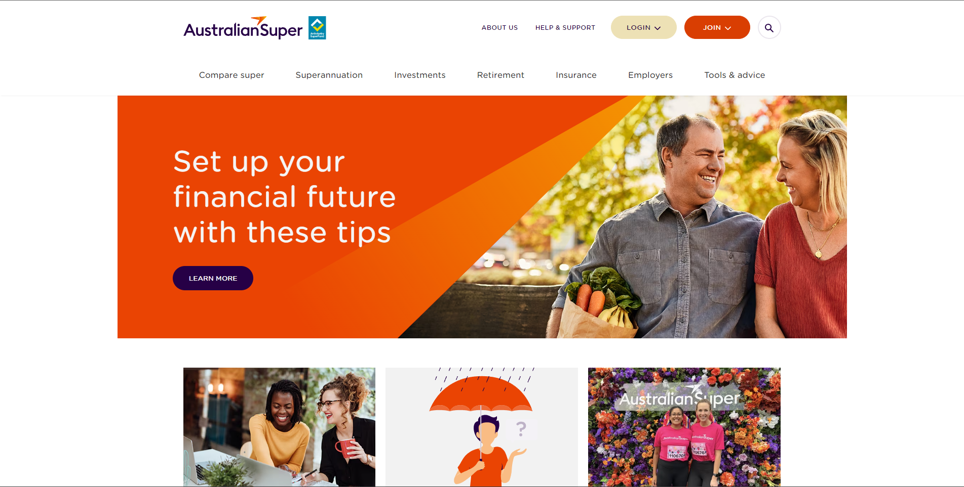

The goal of the website is easy to see, large and in the center.

A join button is clearly visible at the top right, dark orange against the white background. This also brings your attention to the login and search.

The navigation bar is very verbose and takes up a lot of the screen.

Although this means it is easier to find needed information without having to click through many different pages. Looking at you https://www.adelaide.edu.au/

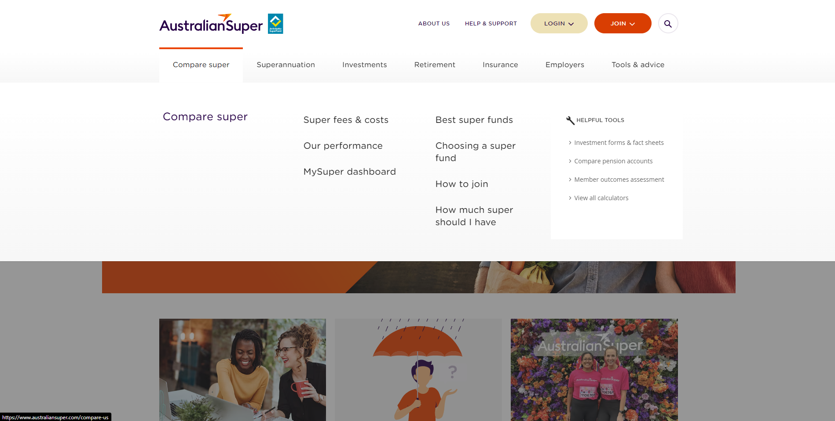

A short scroll down yields more information.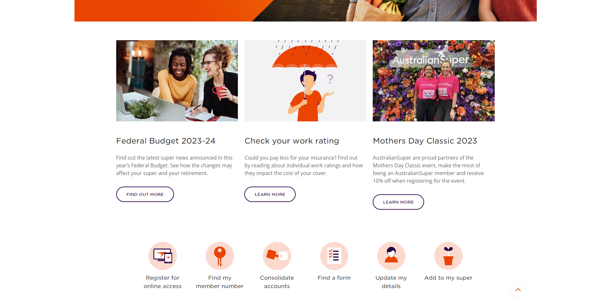

Such as more information you may want to know.

Alongside some quick links to other parts of the website for users.

# Joining a Club on adelaide.edu.au

This is kind of a walkthrough of trying to join a club online.

<https://www.adelaide.edu.au/clubs/>

Link from googling “University of Adelaide Clubs” and clicking the first link.

Clear title at the center of the screen with the description below talking about clubs.

Clearly in what appears to be the correct place.

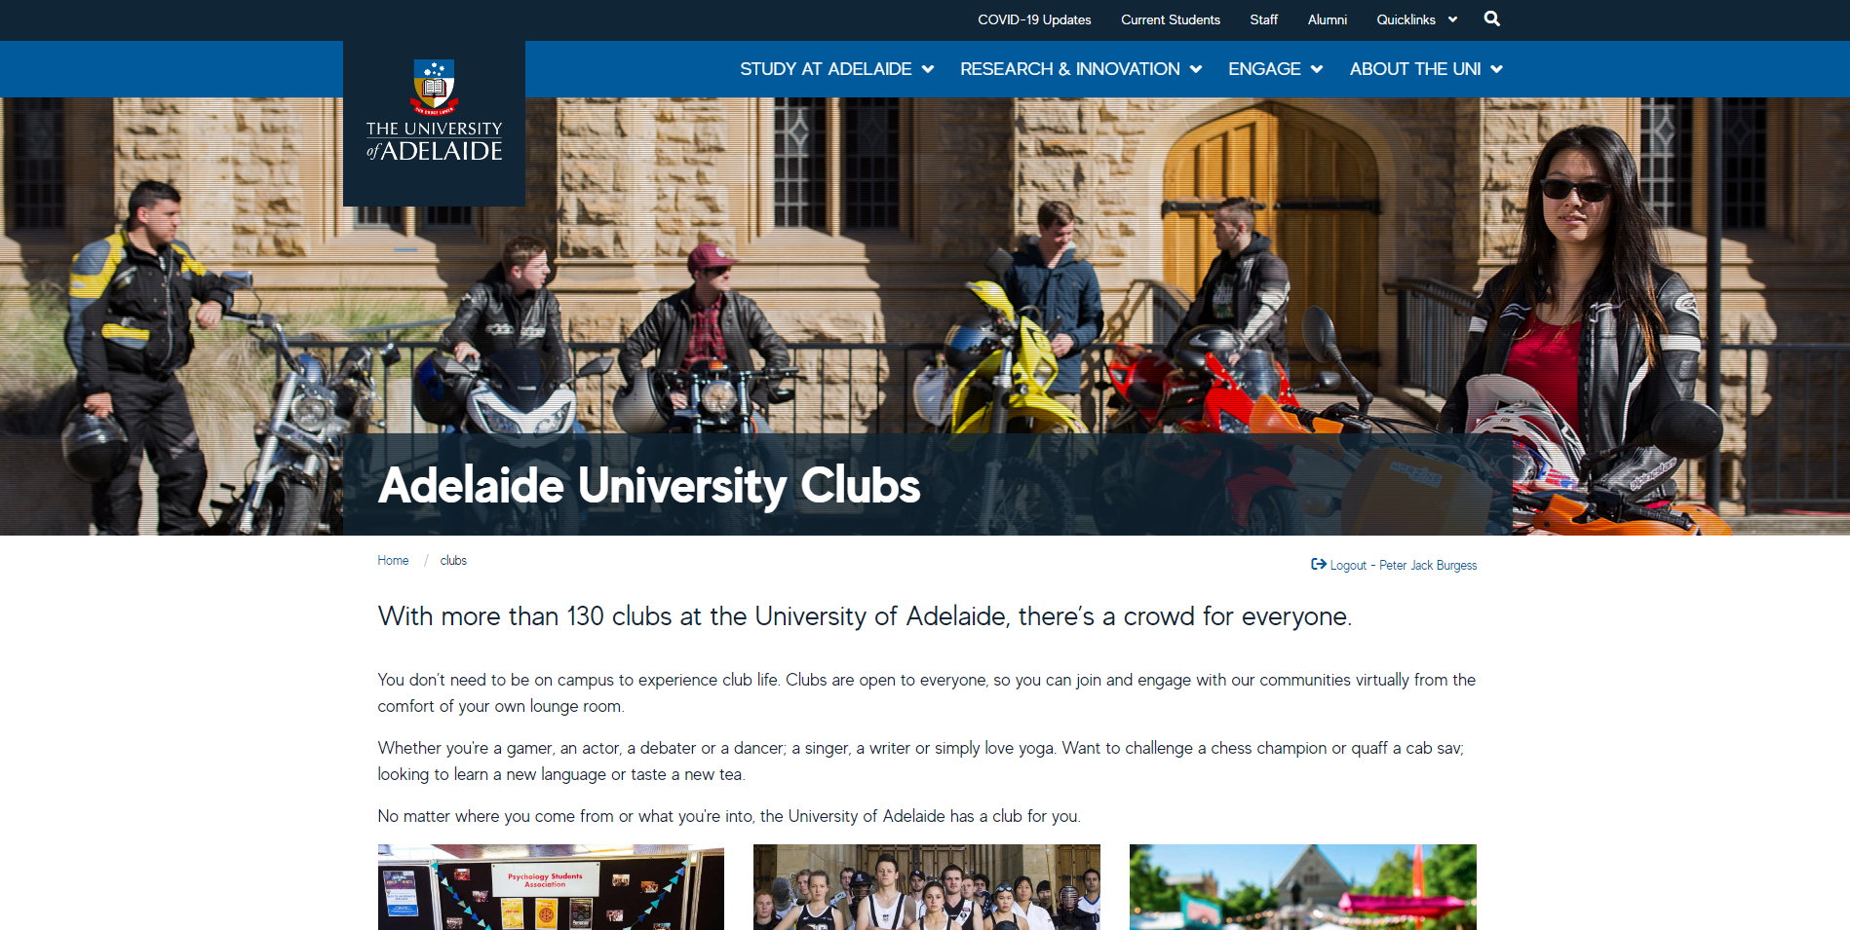

You need to scroll down to find the link to actually join a club.

Not bad, but increases the cognitive load.

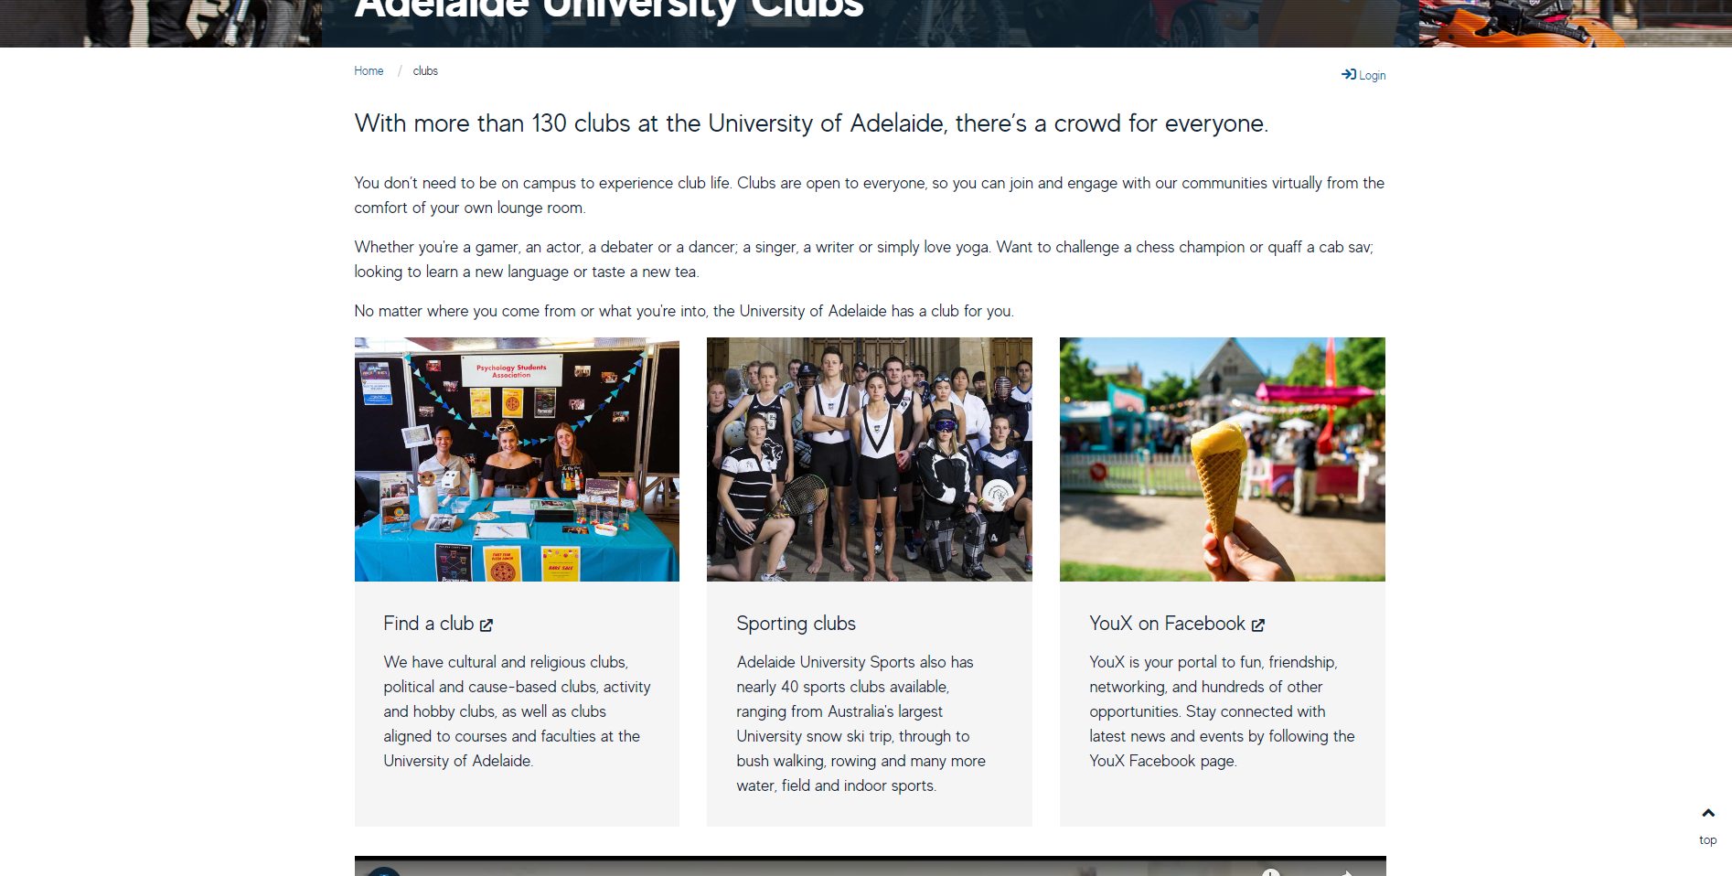

Upon clicking you are redirected to a different website, the title is very clear and easy to see, so it looks like you are in the right place.

Although the transition can be a little jarring.

Finding no way to join a club you scroll down, where, after spending some time reading the section on the left, you find a link to “How to join a club”.

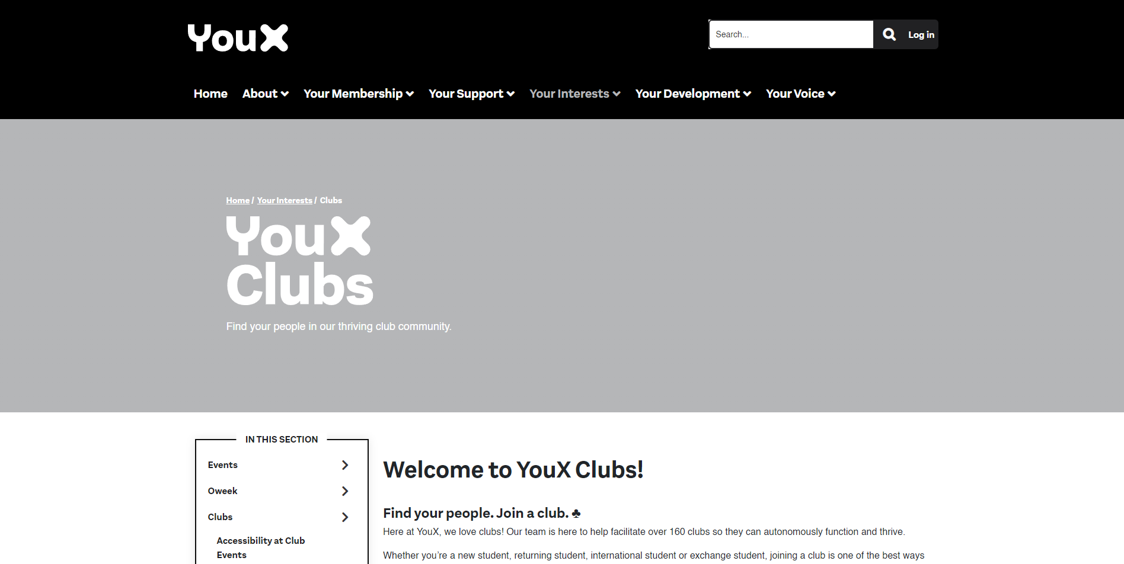

After following the link you are greeted with the following page after scrolling down a little.

Where you do not even find a way to join clubs, just directions on how to find a club.

Let us say you do not have Facebook or Instagram.

So you look for the club index talked about in the “Contact thor club directly”.

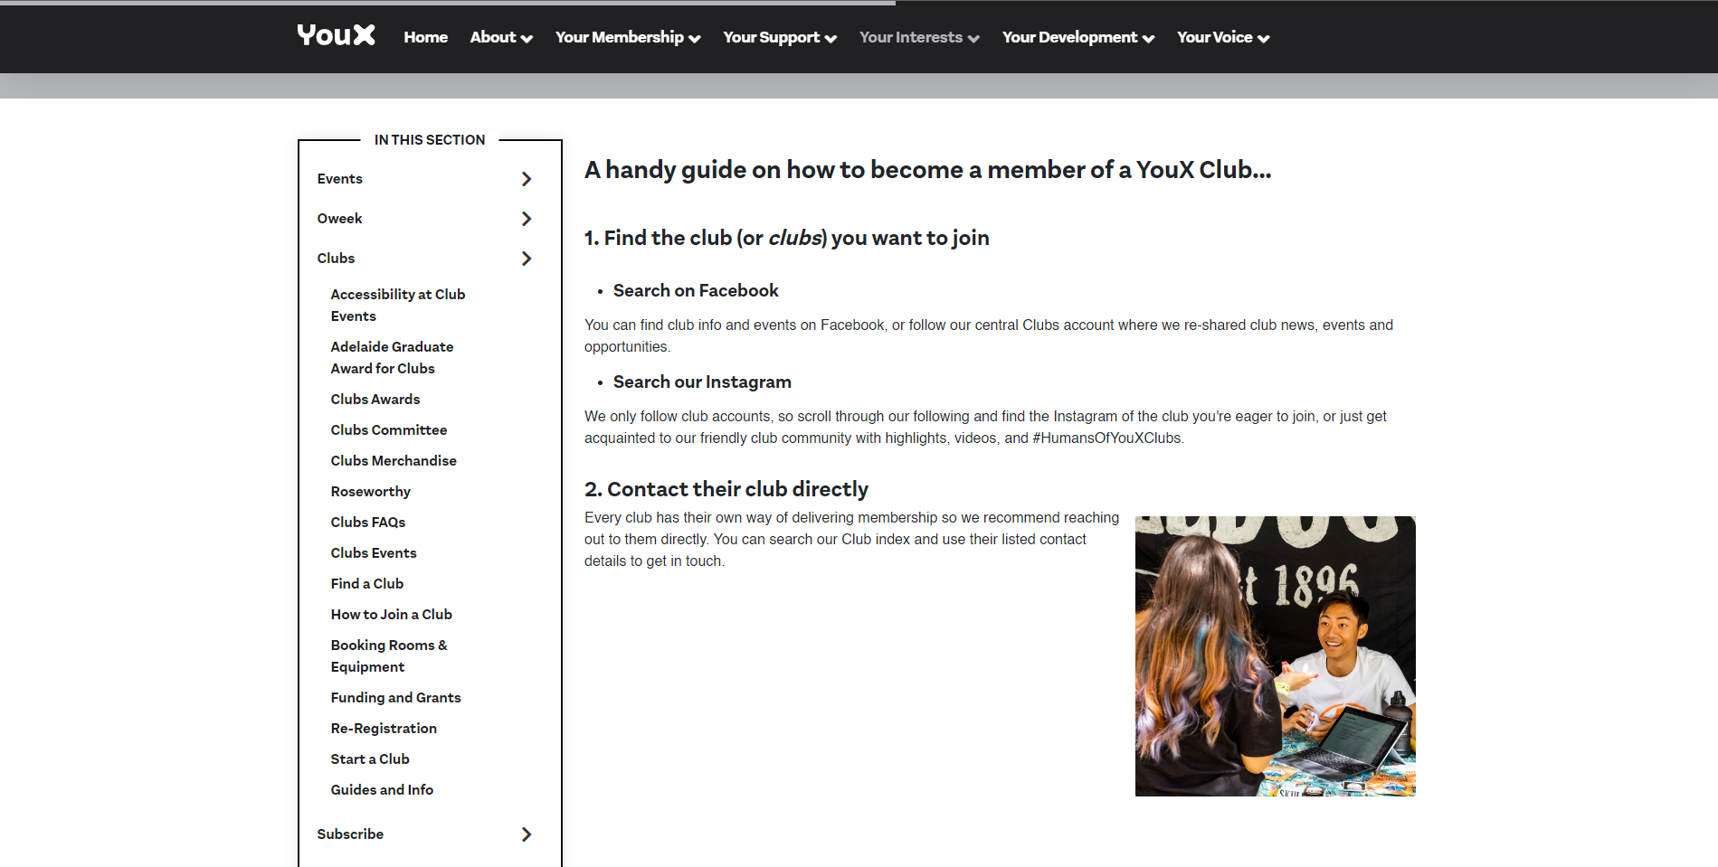

You find nothing about a club index.

So instead you search for something you are interested in.

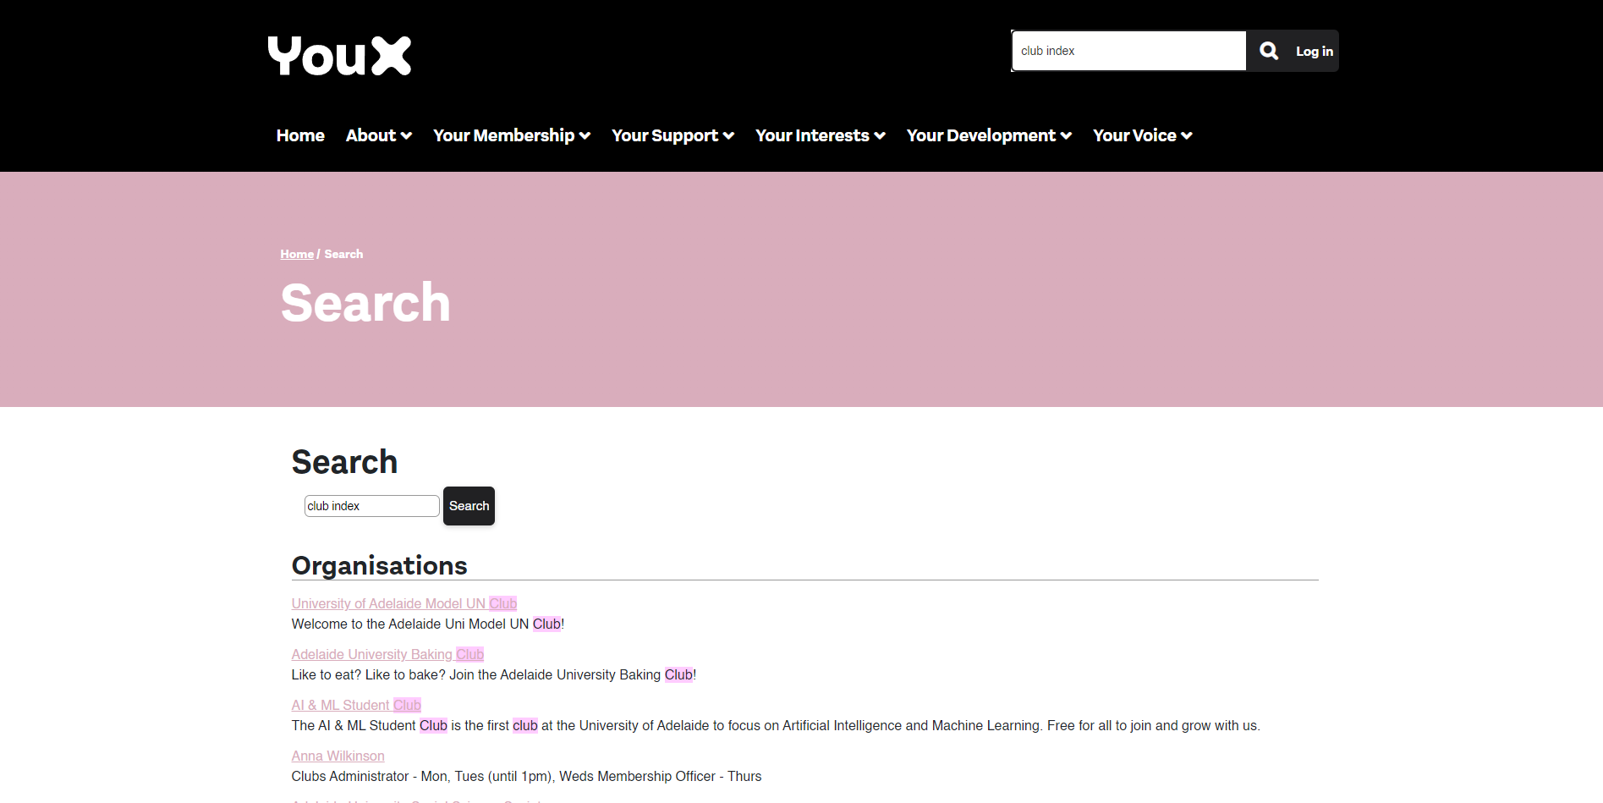

Ohh look, there appears to be a club i am interested in.

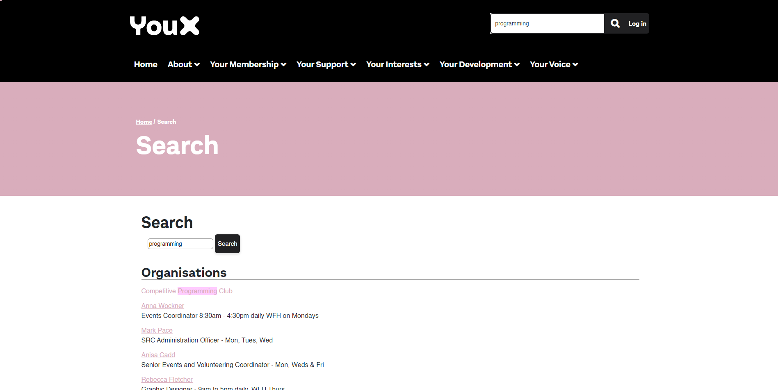

Finally, after clicking on the club you finally get to a club page.

Where there is not even a way to join the club.

It just directs you to contact them.

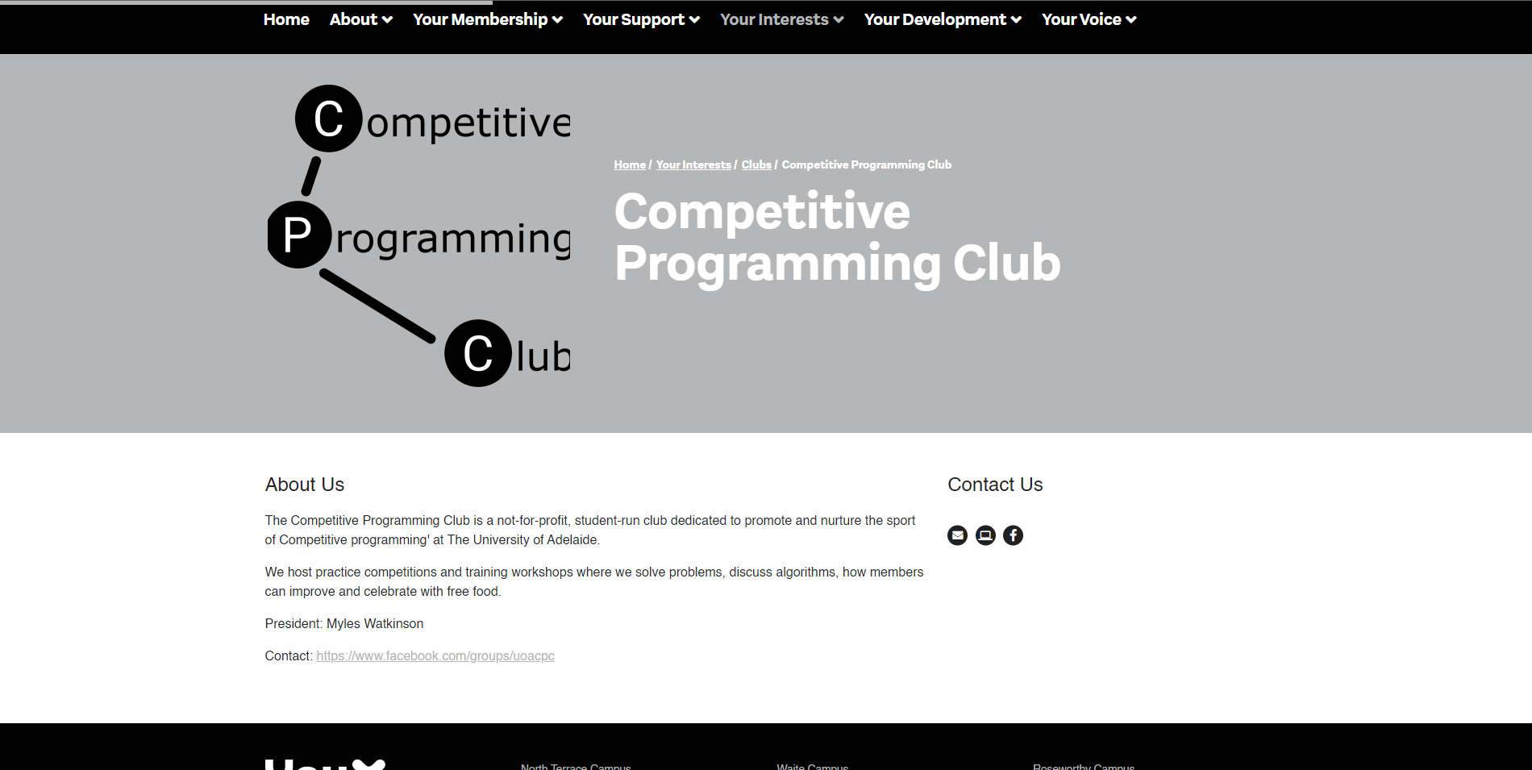

So finally after all that you either have to look for them in person or create a way to contact them online.

It would be so much better if you did not have to go through 6 different pages searching for the information you seek.

You have to constantly search for the information you seek, scrolling up and down pages all the while.

I may have missed it, but I could not find the club index that was talked about.

The sites look very nice, however navigating them to join a club was difficult.

When designing it would be best to prevent such a thing from happening, like there should be a clear line from main page to your goal, in this case joining a club.

# Log in and Sign up

So looking through the inspiration for my log-in pages. I found that my uni/ my adelaide pages have the best interface in my opinion. Having a picture in the background lightens the page up and it makes it less harsh on the eyes. It also gives the user an obvious area where they would need to focus on.

This idea was also followed through in my sign-up page.

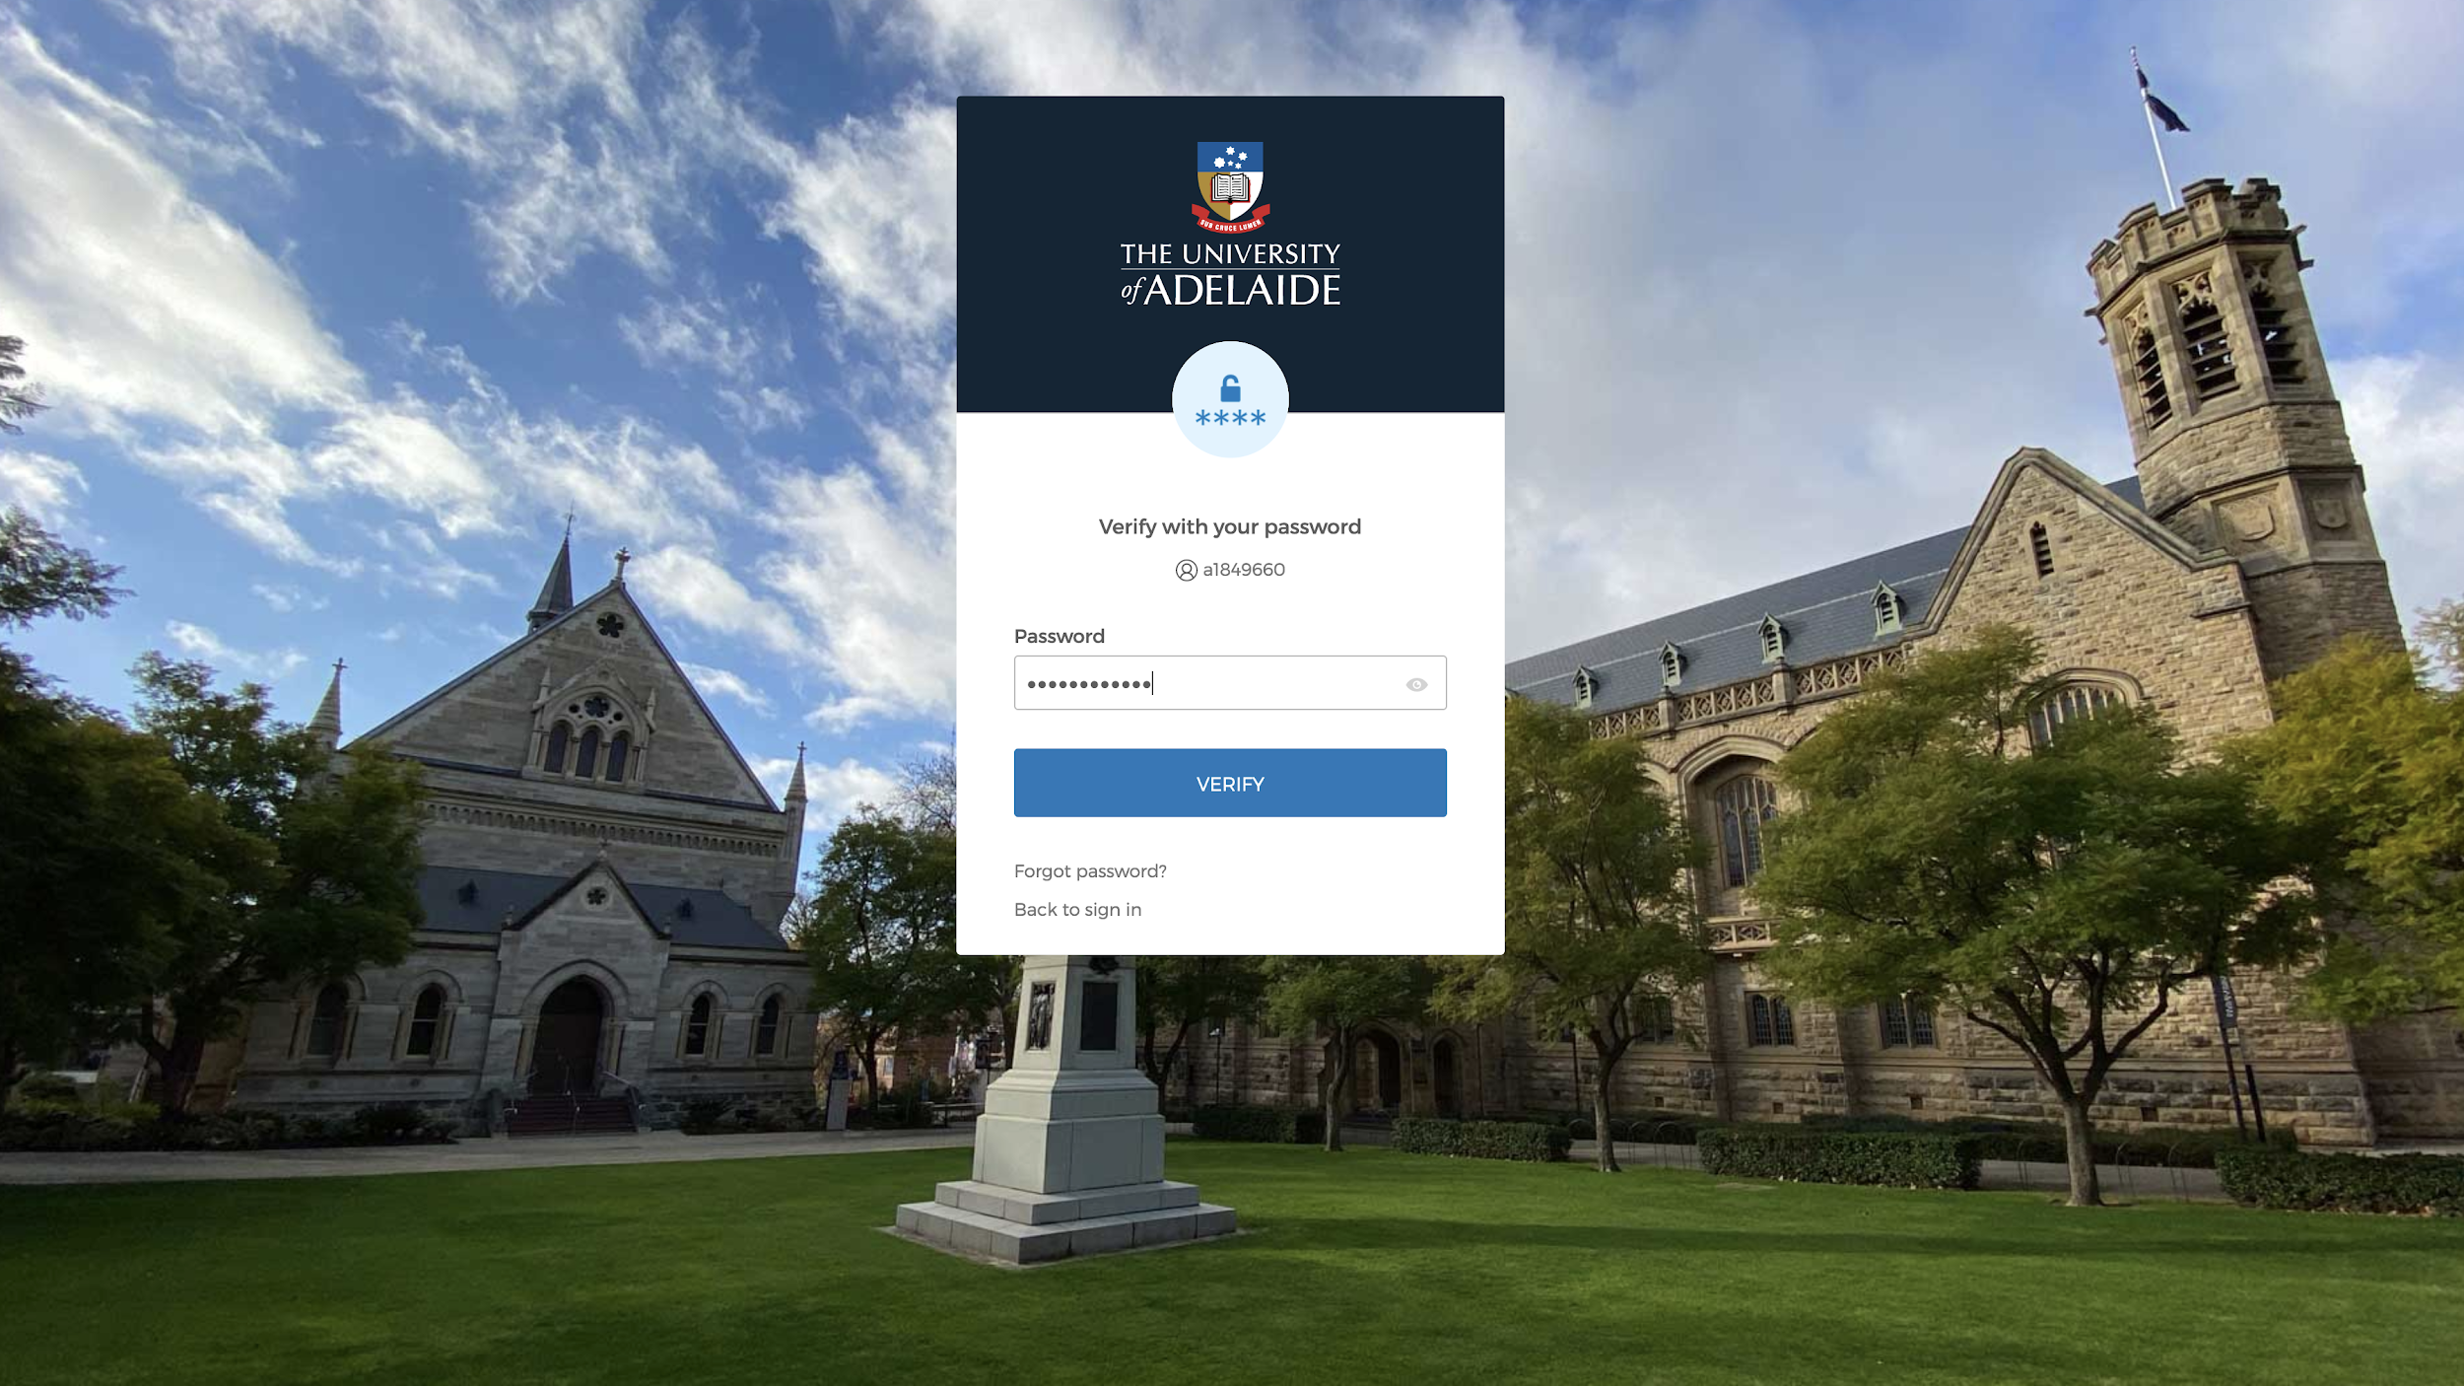

I made the borders rounder though, this gives it a more aesthetically pleasing look.

The round borders I took from the Discord UI as seen below. The whatsapp UI also proved to be useful for my colour scheme as the slightly dull down colours are a lot easier on the eyes and they don’t strain the eyes as much.

